**Name: Nehaar Gosai**

**Student Number:**

**ST 10359529**

**WEDE5020**

**Part 1**

**Table Of Contents**

Website choice 3

Website assets 5

Website pages and contents 5

Reference 5

# Website choice

***ESSAY ON AN EXISTING NPO***

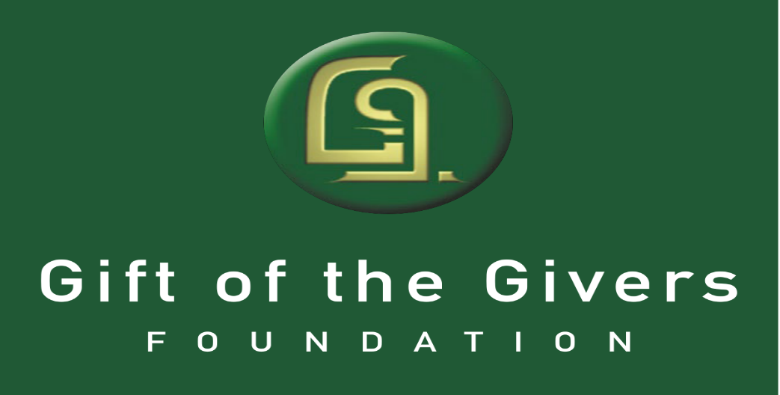

The growth of the internet is unbelievable and can create limitless opportunities for anybody. A website has many advantages and by creating a user-friendly website the Non-Profit Organization will be able to create an opportunity to secure donors and sponsors for the organization worldwide and not limit itself locally. The website must be designed so that people can seek help easily from the organization with just a few clicks.

Creating a website for a Non-Profit Organisation, such as GIFT OF THE GIVERS is a brilliant idea. The website will assist the organization in getting its mission statement known to people and other organizations around the world with a click of a button. The Non-Profit organization will be able to add their stories and pictures of what they do on a regular basis. When a non-profit organization becomes world-recognized, people and businesses from all around the world want to find out about the organization and what they do for people and countries that are in need.

As the website gain popularity, the organization will be able to engage with other organizations that share the same principles and goals. This will assist the organization in creating branches around the world. Creating a chat feature on the website will assist people more effectively and efficiently around the world when required.

The website will have a chat room for people, donors, and sponsors to propose new ideas or change current projects undertaken by the organization. In the ever-changing environment of the internet, it will be imperative to Link the website to social media which will assist the organization in posting real-time events.

The organization can add an events calendar listing its current and future missions. This will assist in acquiring the necessary skill required for each event.

In conclusion, every organization and business should build a strong website to assist in growth.

Thank you 😊

## Website assets



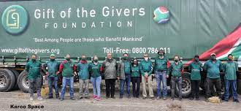

### Website pages and contents

1. Homepage
2. Contact us
3. About us
4. Services
5. donations

#### Reference

* *Gift of the givers foundation* (2023) *Gift of the Givers Foundation*. Available at: <https://giftofthegivers.org/> (Accessed: April 3, 2023).

**Part 2**

**Improvements:**

* I have added a gallery page.
* In the gallery page there is a video with sound.
* I added a background picture throughout the website.
* I changed the homepage by adding more pictures and changing the logo.
* I changed some font from black to white so that people can read it.
* I changed the font size
* I put some writing to the center and some to the right.